GALERIJA SINGIDUNUM, Kneza Mihaila 40, Beograd
Konkurs za izbor projekata za 2024. godinu: samostalna izložba

K O N C E P T I Z L O Ž B E
PLAVI GRAD
dr Katarina Andjelkovic, master ing.arh., master primenjenog slikarstva

Ekstremni uslovi nezapamćene kišne oluje parališu grad. Pogođena postapokalitičnim poplavama, gradska infrastruktura iznenada raste, progušćuje se i nadkriljuje građevine. Na taj način, infrastruktura podržava kretanje vode u horizontalnom i vertikalnom pravcu i sistemom cevi ispumpava vodu iz naseljenih područja. Otvoreno je pitanje: da li boja u slikarstvu može ponuditi put otkrića vode kao arhitekture, odnosno kako elementi prirode poput vode mogu postati arhitektura koristeći likovni jezik? Integrisanjem raznovrsnih nijansi plave u gradsku strukturu, infrastrukturu i apstraktnu tektoniku, bavim se prikazom arhitektonskih elemenata u odnosu na polivalentno značenje boje, formalne i materijalne kvalitete slike. U igri mozaičkih apstraktnih ravni i kolažnih fragmenata, plava boja prerasta u konstruktivnu mrežu koja nosi ogoljene raspadajuće strukture građevina. Ove progušćene infrastrukturne mreže spekulišu načine na koje voda postaje arhetip procesa rekonstrukcije grada nakon katastrofa uzrokovanih poplavama. Istraživanje arhitektonske reprezentacije ponovo je uvelo slikarstvo kao način razmišljanja o prostoru, svetlosti i boji. Ipak, slike su esencijalno moderne i modernističke: to su slike fragmenata, kolaža, asamblaža, delova koji predstavljaju celinu mozaičkih apstraktnih ravni i pravougaonih formi. Projekat se sastoji od 8 prostornih sekvenci u kojima se neočekivana okruženja i mesta pretvaraju u aktivne protagoniste.

Program izložbe 21-29. juni 2024
Autor će održati i multimedijalno predavanje pod naslovom „Reprezentacija slike između realnih i digitalnih okruženja“ u sklopu pratećeg programa. Svi prikazani radovi su publikovani u internacionalnim naučnim casopisima (Arts & Humanities Citation Index, Web of Science) i izlagani u okviru internacionalnih izložbi umetnosti i arhitekture.

Biografija autora
Katarina Andjelkovic, with a Ph.D., M.Arch.Eng., M. Applied Arts, is a theorist, practicing architect, researcher and painter. She is a high-skilled draftsman, writer and researcher. Andjelkovic is simultaneously engaged in architectural practice, teaching, and research. Katarina’s research, writing and teaching, focus on how ideas can be translated across different media, crossing architecture, visual arts and film. Katarina is currently a MUSAE artist-in-resident (Politecnico di Milano). Katarina has extensive experience in teaching architecture and visual arts: as a Visiting Lecturer at Coburg University of Applied Sciences - Faculty of Design (Department of Architecture) in Germany (2023); as a Visiting Professor at Epidemic Urbanism Initiative (Columbia University and Morgan State University, U.S.); as the main instructor of the HAND-DRAWING COURSE at SMT New York, U.S. (2021), a Visiting Professor and Chair of Creative Architecture, University of Oklahoma (2017), Institute of Form Theory and History in Oslo, Institute of Urbanism and Landscape in Oslo, Norway, at The University of Belgrade - Faculty of Architecture. Katarina is guest-lecturing and mentoring at TU Delft - Faculty of Architecture and the Built Environment, AHO - Oslo School of architecture and design, FAUP Porto, DIA Anhalt Dessau, ITU - Istanbul Technical University. She lectures internationally at conferences in more than 40 countries in Europe, United Kingdom, North America, Canada, Australia, China, and South America. Katarina has published her research widely in international journals (Web of Science). She is a full author of the Preliminary Architectural Design, a national project supported by the government of Serbia. She won the Belgrade Chamber of Commerce Award for Best Master Thesis defended at Universities in Serbia in all disciplines. Katarina has published 3 monographs and book chapters with Intellect United Kingdom, University of Chicago Press (U.S.), Routledge, Taylor and Francis Group (London, United Kingdom), Büchner-Verlag eG, Marburg/Germany, etc. During her Ph.D., Andjelkovic's research stays were all at European universities in Copenhagen, Ljubljana, Porto, Dundee U.K., Brighton U.K., Dublin, Madrid, etc. Andjelkovic exhibited her artwork at 8 Solo Exhibitions and at more than 80 international architectural, fine arts, and photography exhibitions, including group exhibitions at Pall Mall Gallery in London, Royal Hibernian Academy in Dublin, MAAT Museum in Lisbon, International Biennial of Illustration ''Golden Pen'' in Belgrade, Loughborough University in the United Kingdom, TU Delft in the Netherlands, the Museum of Applied Arts in Belgrade, the National Museum in Belgrade, Prodajna Galerija "Beograd" (Kosancicev venac, Belgrade), Gallery Singidunum in Belgrade, Stepenište in Art Education Center ''Šumatovačka'', Gallery of the Central Military Club, Suluj Gallery, Pavillion Cvijeta Zuzoric of the Association of Fine Artists of Serbia, etc. Katarina is a recipient of EDRA’S 2022 AMBASSADOR FUND AWARDS [California, U.S., Awarded in South Carolina], THE ULUS 2021 Spring Exhibition Award “INVISIBLE PORTRAIT” [awarded by Association of Fine Artists of Serbia], and won numerous awards for her architecture design and urban design competitions.

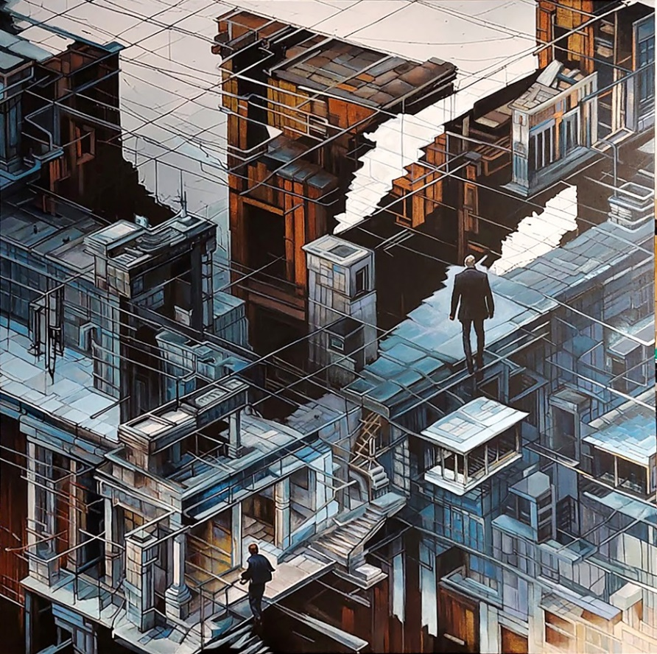
Katarina Andjelkovic, Plavi grad, 2023-24. Akril i pasta na platnu, 100x100 cm.

dr Katarina Andjelkovic
katarina.code@gmail.com
mob. 065/ 8795 874

